## ****Scraping Tweets from Twitter****

Following are the steps that you need to perform before you can scrape tweets from Twitter:

### **Creating a Twitter Developer Account :**

The first thing that you need to do is create a Twitter developer account. To do so, you need to go to [Twitter developer website](https://developer.twitter.com/content/developer-twitter/en.html) and create your account.

To create a developer account, you will have to verify your cell phone number and will have to answer a few basic questions regarding why you need a developer’s account etc. Next, you will have to agree to their terms and services. Finally, you will receive an email in your account for the verification of your account.  Got to your email and confirm your account. Your application for the developer account will be reviewed by the concerned authorities as shown below:

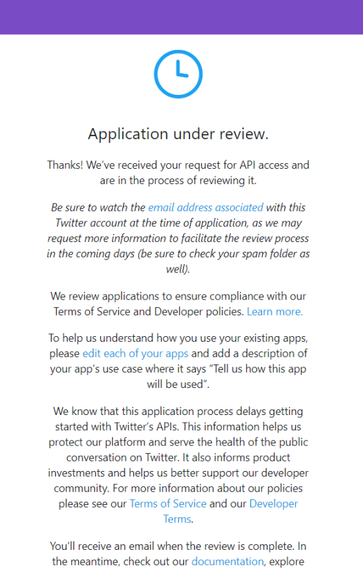

### **Creating a New Twitter Application**

Once you have created your developer account with Twitter, follow these steps to create a new Twitter Application:

1. log into your account and go to [this link](https://developer.twitter.com/en/apps) to create a new Twitter application.  Click on the “Create an app” button on the top right.
2. You will be presented with a form where you have to enter the App Name, Application description, Website URL. For the sake of this tutorial, I named my application “twitter-scraping-xyz”. For website URL, you can add any place holder name as well. I used “www.google.com” for website URL. Add any description for the app and click the “Create” button at the bottom. Leave the rest of the fields. They are not necessary.

### **Getting  API Keys and Access Tokens**

To connect with your Twitter Server application from a client application such as Python, you will need consumer API keys and Access tokens. To do so, go to the application page; click on the “Keys and tokens” menu from the top. You will see API Key and API Secret Key on the page. For Access Token and Access Token Secret, you will have to click on the “Create” button as shown below:

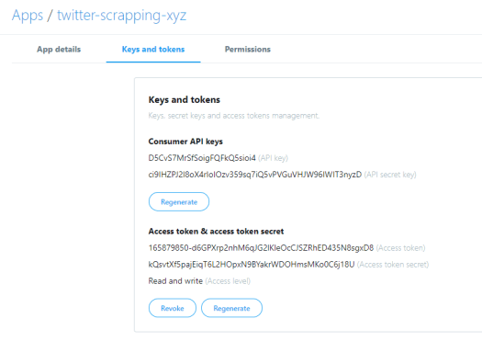

Before proceeding to the next section, you should have Consumer API key, API Secret key, Access token, Access token secret.

### **Connecting Python Client Application to Twitter Server**

Now as you have everything, you need to connect to the Twitter server and fetch live tweets. The library we will be using to connect to the Twitter server and scrape live tweets will be [Tweepy](http://www.tweepy.org/" \t "_blank). The library can be downloaded using the following command:

Python

